CIRCUIT DIAGRAM

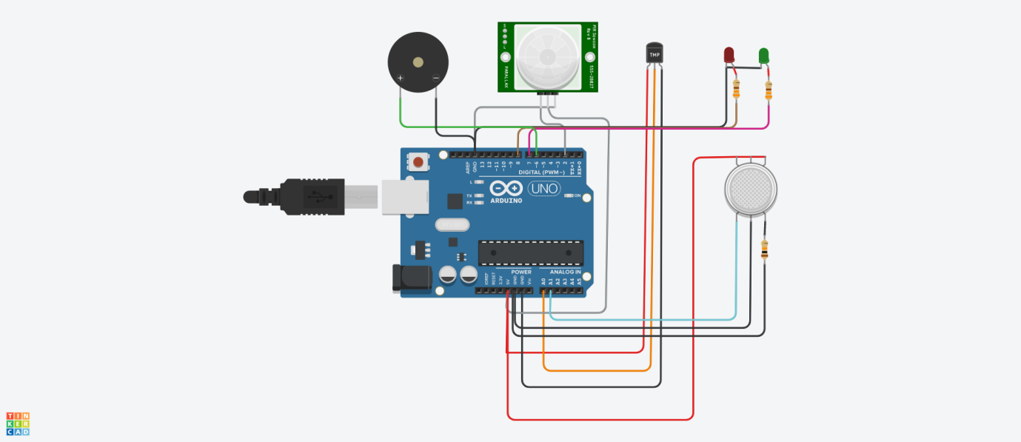

PROGRAM

void setup() {

Serial.begin(9600);

pinMode(A0, INPUT);

// put your setup code here, to run once:

}

void loop() {

int a;

a = analogRead(A0);

a = a \* 0.49;

Serial.print("Temp:");

Serial.println(a);

delay(1000);

if (a > 30 && a < 45)

{

Serial.println("temp is normal");

}

if (a > 45 && a < 60)

{

Serial.println("temp is high");

}

if (a > 90)

{

Serial.println("temp is critical");

}

}